Reading at Long Whatton Primary School
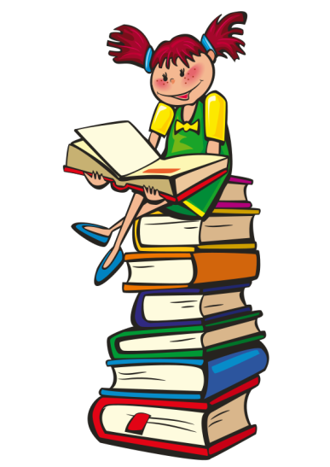
We all need to become good readers, but more than that we need to be able to appreciate and enjoy good literature throughout our lives. To this end we promote reading as time well spent, we model good reading and we give children the building blocks to become accomplished readers.
The majority of children leave our school reading at a level beyond that which is normally expected for their age.
When children begin school we think it is important that they see reading as fun and not a chore. Children develop at different rates, so don’t worry if your child doesn’t begin to read straight away. Initially we want children to be picking up books and enjoying looking at the pictures, pretending to read even. Some children learn their sounds very quickly and begin to decode words easily, some children rely more on picture cues and making sense of what they can see and hear and work out the story based upon this. For most it is a combination of strategies that help children to learn to read, and we would not discourage a particular learning style. If your child’s teacher thinks that there may be a problem, they will always contact you and discuss this and the next steps, which may involve some further analysis or testing to help us decide if there may be a learning difficulty. At some point this may involve an outside agency coming to support us in doing this in school and to decide what we can do to help your child progress.
In our EYFS class (the Busy Bees) children begin to learn their sounds using ‘Jolly Phonics’, one of the recognised schemes. This learning continues through the school where teachers use ‘Letters and Sounds’, another very popular scheme that is used in many schools. Children will progress through 5 phases of learning phonics, regardless of which year group they are in and following this, they go on to be challenged in extended spelling groups.
Our core scheme is the Oxford Reading Tree, but this is supplemented by many other schemes, all of which along with the ORT are organised into book bands. Our children are encouraged to read widely across many schemes, rather than moving too quickly from one stage to the next. Reading across book bands is the norm, as this allows children to read lots of different types of books, including non-fiction books and to deepen their learning. Our books are clearly displayed and children and parents know where to choose books from. Children read as much as possible and the school is lucky to be volunteer rich, which enables us to make sure that children share books and read with adults regularly. Younger children may also ‘buddy’ with older children, and share books, something which is enjoyed by everyone.

As children progress through the book bands they choose increasingly from our library aswell. Children are encouraged to read at home and bring books in to share. Children have reading diaries and have the opportunity to take part in regular reading competitions and events, such as the Extreme Reading Challenge - What is the most extreme place you have ever read a book? We have book review competitions and most recently we have started an inter school book club to stretch our higher attaining pupils.
We want to open the door to a whole world of literature for our children.
Here are some user friendly guidelines to support your child’s reading.
- Choose a quiet time and keep sessions short. Ten minutes is plenty or your child will begin to lose concentration. Try to hear your child read regularly, every day if possible.
- Don’t cover up the pictures. Look at them together first and talk about them. This will help your child to understand what the book is about and enable them to be more successful when reading the words.
- Ask questions about the characters and discuss what might happen next.
- Encourage your child to relate what they read with their own experiences. Responding to the text is an important skill to develop.
- Encourage your child to point to the words as they read.
- Encourage your child to read some words by sounding them out aloud, using the sounds of the letters e.g. b-a-g. Be aware though that this doesn’t work for lots of words e.g. was, who, what, the.
- If they get a word wrong, let them carry on reading the sentence before you correct them. Often they will realise that they have made a mistake and go back and correct themselves. If not, say “Does that make sense?”
- Help your child to use known familiar words to work out new ones: eg. look - book, took, cook and - stand, band, hand
- Don’t let them struggle for too long over an unknown word. It’s fine to tell them some
words so that they don’t lose confidence.
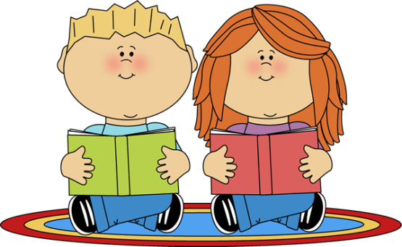
- There is no need to correct every mistake as long as what they have read makes sense. It is far better to praise accurate attempts.
- Most important of all, make sure that reading is an enjoyable experience for your child.
- Don’t let your child become anxious about reading. Give lots of praise and encouragement and make it fun!

